Government Polytechnic Awasari (Khurd)



**A PROJECT REPORT ON**

**“ Movie Recommondation System’’**

**By**

|  |  |
| --- | --- |
| **Name Of Students** | **Enrollment No.** |
| Kodre Pritee Vishwambhar | 1610510163 |
| Gaikwad Sanket Rajenrda | 1810510271 |
| Adak Shubham Anil | 1810510275 |
| Patil Aditya Sntosh | 1810510238 |

**2020-2021**

**GUIDED BY**

**DR. D. N. REWADKER**

**DEPARTMENT OF INFORMATION TECHNOLOGY**

**DESIGN AND IMPLEMENTION OF “MOVIE RECOMMONDATION SYSTEM”**

**PROJECT REPORT**

**SUBMITTED IN PARTIAL FULFILMENTOF THE AWARD OF DIPLOMA**

**IN**

**INFORMATION TECHNOLOGY**

**SUBMITTED BY**

|  |  |
| --- | --- |
| **Names Of the Student** | **Enrollement No.** |
| Kodre Pritee Vishwambhar | 1610510163 |
| Gaikwad Sanket Rajendra | 1810510271 |
| Adak Shubham Anil | 1810510238 |
| Patil Aditya Santosh | 1810510275 |

**GUIDE**

**Dr. D. N. Rewadkar**

**DEPARTMENT OF INFORMATION TECHNOLOGY**

**GOVERNMENT POLYTECHNIC AWASARI(KH)**

**(2020-2021)**

**GOVERNMENT POLYTECHNIC** **AWASARI(KH)**



**CERTIFICATE**

This is to certify that,

|  |  |
| --- | --- |
| **Name of Students** | **Enrollment No** |
| Kodre Pritee Vishwambhar | 1610510163 |
| Gaikwad Sanket Rajendra | 1810510271 |
| Adak Shubham Anil | 1810510238 |
| Patil Aditya Santosh | 1810510275 |

Of the final year Information Technology Student have submitted their project reporton

**“Movie Recommendation System”**

During academic session 2020-2021 as a part of project work described by Government Polytechnic, Awasari(Khurd) for partial fulfilment for the diploma in Information Technology in the sixth semester.

This project work is the record of the students own work under my guidance and satisfaction.

**------------------------ -------------------------- ---------------------**

**Guide Head Of Dept Principal**

**Mr. D.N.Rewadkar Dr.D.N.Rewadkar Dr.D.R. Nandanwar**

**GOVERNMENT POLYTECHNIC AWASARI(KH)**

**CANDIDATE’S DECLARATION**

**I hereby certify that the work which is presented in the project report entitled “Movie Recommendation System” by us partial fulfilment of requirements for the award of diploma in information technology submitted in the Department of Information Technology is an authentic record of our own carried out during (2020-21) guided by Dr. D. N. Rewadkar.**

|  |  |
| --- | --- |
| **Name of the Students** | **Enrollment No.** |
| Kodre Pritee Vishwambhar | 1610510163 |
| Gaikwad Sanket Rajendra | 1810510271 |
| Patil Aditya Santosh | 1810510275 |
| Adak Shubham Anil | 1810510238 |

**This is to certify that the above statement made by the candidate is correct to the best of our knowledge.**

**Signature of the GUIDE**

**ACKNOWLEDGEMENT**

It gives us an immense pleasure to express our sincere and heartiest gratitude towards our Project Guide Mr. D.N.Rewadkar for their guidance, encouragement, moral support and affection during the project planning. They have proven to be an excellent guide and teacher. We are especially appreciative to their willingness to listen and guide us to find the best solution, regardless of challenge. We also thankful of our project guide for providing us opportunity to work with them.

We also extremely grateful of Dr. D. N. Rewadkar**.** Head of Information Technology Department, for their motivation and support during the work of Capstone Project Planning from time to time and for giving her precious knowledgeable hands to our work.

Lastly, our cordial thanks to all who have contributed indirectly and materially in words and deeds for completion of Capstone project planning.

**Group Members**

|  |  |
| --- | --- |
| **Name of Students** | **Enrollment No** |
| Kodre Pritee Vishwambhar | 1610510163 |
| Sanket Gaikwad Rajendra | 1810510271 |
| Patil Aditya Santosh | 1810510275 |
| Patil Aditya Santosh | 1810510238 |

**ABSTRACT**

This project is developed using Servlet with HTML, CSS, Javascript, Python.The Movie Recommendation System is a webbased application that can be accessed over the web. This system can be used to automate the workflow of colleges and their invoices.

The project has been planned to be having the view of distributed architecture, with centralized storage of the database. The application for the storage of the data has been planned. Using the constructs of MySQL Server and all the user interfaces has been designed using the PHP technologies. The database connectivity is planned using the “MySQL Connection” methodology. The standards of security and data protective mechanism have been given a big choice for proper usage. The application takes care of different modules and their associated reports, which are produced as per the applicable strategies and standards that are put forwarded by the administrative staff. This is a web-based application which manages. It has one module i.e. admin who manages all the functions of this system…

**Key Words:** Analysis, Movie Recommendation,K-means Clustring, Machin Learning algorithm, API.

**CONTENT**

|  |  |  |
| --- | --- | --- |
| **Chapter** | **Title** | **Page No.** |
| 1 | Introduction | 2 |
| 2 | Literature survey | 4 |
| 3 | Scope of project | 5 |
| 4 | Methodology | 6 |
| 5 | Details of desing working and processes | 7 |
| 6 | Result and application | 14 |
| 7 | Test case of the project | 29 |
| 8 | Conclusion and future scope | 30 |
| 9 | References | 31 |

**INTRODUCTION**

**Problem Statement**: Develop a project to Movie Recommendation System.

* This system will recommend movie on k-means clustering algorithm.
* This is movie recommendation system. The main aim of this project to develop website that will allow to watch movie this website is mainly built on reacts framework.
* The mainly used languages are HTML, CSS, Bootstrap, Java, react JS languages.
* This system will overcome existing content providing platforms by providing watch time regulations.
* The database of the system can be easily maintained and can be extend in future for up-coming content.

This system totally automated and there is requirement of provisions, the only task in system will add more content, regular the content and check whether content is violating content policy.

**LITERATURE SURVEY**

|  |  |  |  |  |
| --- | --- | --- | --- | --- |
| **Sr.No.** | **Type of document**  **And Publisher** | **Topic/Conclusion of ppt** | **Author Name** | **Retrieval for Our**  **Project** |
| 1 | IEEE | This paper designs and develops a Movie Recommendation system for undergraduates’ | Hongfu Wang | Responsibilities of the four categories of users, workflow, design ideas, and discusses some design methods to enhance the security of the system. |
| 2 | IEEE | In this research ppt they studied about the exciting used and new system developed | Haidarali Nadir Shah | Survey of all such web-based project management system and proposes a system |
| 3 | IEEE | In this research ppt they studied the various Information about Movie Recommendation | Faisal Latif Khan | Many techniques for automating the project management system by providing features such as real-time. |

**SCOPE OF THE PROJECT**

Recommendation system help E-commerce sites to increase their sales. A Movie Recommendation system named MOVREC, based on collaborative filtering approach makes use of the information provided by users, analyses them and then Recommends the movie that is best suited to the user at that using K-means clustering algorithm, Which is used in machine Learning. In this project we use the database. We implement the K-mean Clustering Machin Learning algorithm in python ,Then we create the API and link it to Javascript and after this whole process we upload our whole code on Git-Hub then we host our website for the use of users.

**METHODOLOGY**

Our project is based on Recommendation System, Here we recommend the movie to the

users by observing their previous search, Their two type of recommendation System

1. Item Based recommendation System
2. Collaborative recommendation System

In the first type Recommendation System, It’s based on rating data and then recommend to the user, Here we provide the data in the form of rating. It’s based on the similarity between the items calculated using the peoples rating.

In the Second type of Recommendation System, It’s recommends on the basis of collaboration. It’s is filtering technic used in the recommended system, It’s is the method of making automatic prediction or filtering about the interest of a user by collecting preference or information from many users.

Here we Create the API in python In there we pass our data in list and by applying the query we fetch the data. and link it to the Javascript, Style our webpages by using CSS.

Our whole project train the model once and then apply the Machin Learning algorithm , Which make the cluster of the data, Then find the similarities in between and recommend to the users. We host our website and make it available for the usres.

**DETAILS OF DESING WORKING AND PROCESSES**

Diagram Desing:

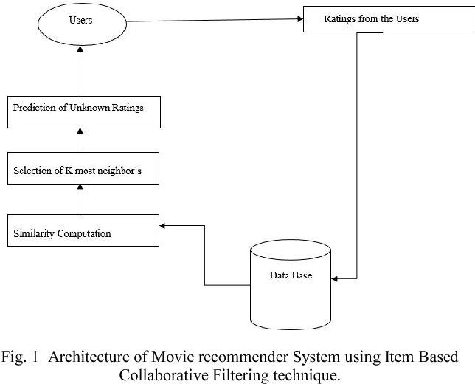

Fig.5.3: E-R Diagram

Start

Movie Name

Processing

Recommend the Movie

Find the similarities

Find The neighbours

K- mean Clustering Algorithm

Fetch The data

Fig 5.4: Use case Diagram

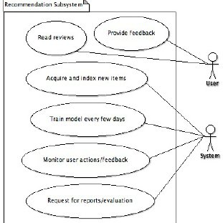

Fig5.5: Class Diagram

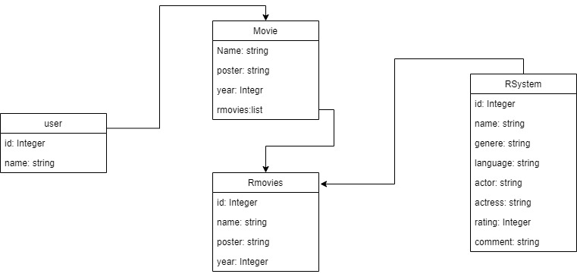

Fig5.6: Activity Diagram

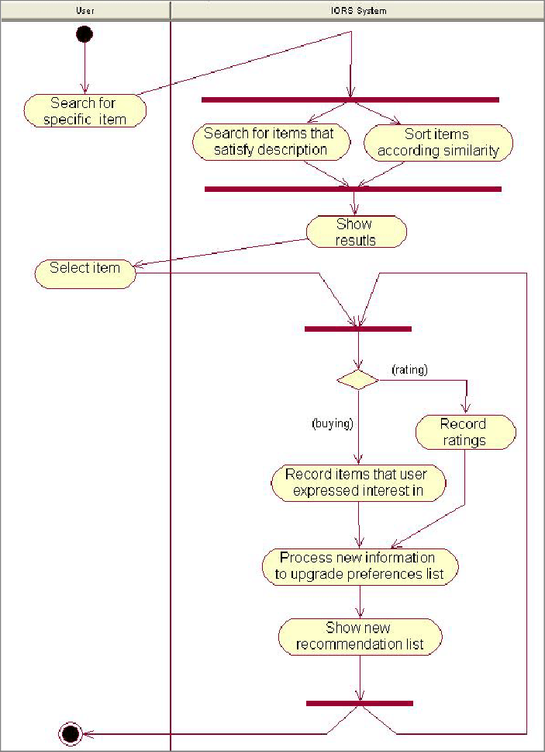

Fig 5.7: Component Diagram

Start

Data

Recommendation Algorithm

Predication

Find the neighbors

Similarities

Recommend movie to the users

End

Fig. 5.8: Deployment Diagram

Start

No recommendation

Recommend the movie

Match

Make the similar clusters

Apply the algorithm

Fetch The Data

**RESULTS AND APPLICATION**

Results/Output:

